**Distribution Plots**

Seaborn is a Python data visualization library based on Matplotlib. It provides a high-level interface for drawing attractive and informative statistical graphics. This article deals with the distribution plots in seaborn which is used for examining univariate and bivariate distributions. In this article we will be discussing 4 types of distribution plots namely:

1. joinplot

2. distplot

3. pairplot

4. rugplot

For Example: We will be using the tips dataset in this article. The “tips” dataset contains information about people who probably had food at a restaurant and whether or not they left a tip, their age, gender and so on. Lets have a look at it. **Code :**

# import the necessary libraries

import seaborn as sns

import matplotlib.pyplot as plt % matplotlib inline

# to ignore the warnings

from warnings import filterwarnings

# load the dataset

df = sns.load_dataset('tips')

# the first five entries of the dataset

df.head()

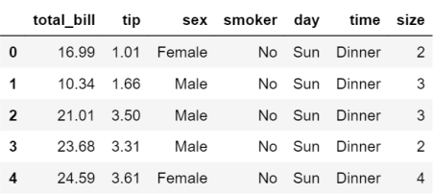

Now, lets proceed onto the plots.

**Displot**

It is used basically for univariant set of observations and visualizes it through a histogram i.e. only one observation and hence we choose one particular column of the dataset.

**Syntax:**

distplot(a[, bins, hist, kde, rug, fit, ...]) # set the background style of the plot

sns.set_style('whitegrid')

sns.distplot(df['total_bill'], kde = False, color ='red', bins = 30)

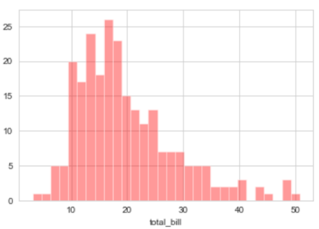

Now looking at this we can say that most of the total bill given lies between 10 and 20.

**Joinplot**

It is used to draw a plot of two variables with bivariate and univariate graphs. It basically combines two different plots.

**Syntax:**

**jointplot(x, y[, data, kind, stat_func, ...]) sns.jointplot(x ='total_bill', y ='tip', data = df)**

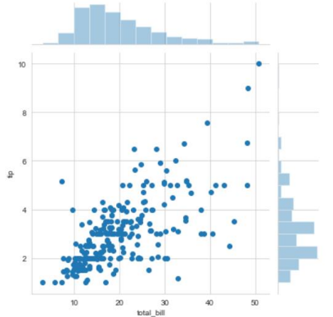**sns.jointplot(x ='total_bill', y ='tip', data = df, kind ='kde')**

**# KDE shows the density where the points match up the most**

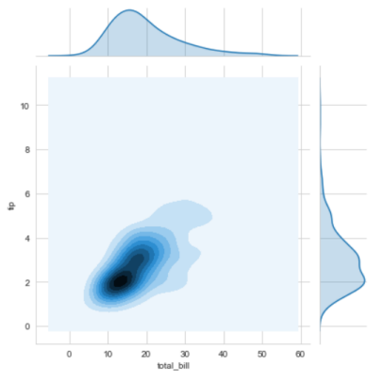

**Explanation:**

• kind is a variable that helps us play around with the fact as to how do you want to visualise the data.It helps to see whats going inside the joinplot. The default is scatter and can be hex, reg(regression) or kde.

• x and y are two strings that are the column names and the data that column contains is used by specifying the data parameter. • here we can see tips on the y axis and total bill on the x axis as well as a linear relationship between the two that suggests that the total bill increases with the tips.

• hue sets up the categorical separation between the entries if the dataset.

• palette is used for designing the plots.